PROGRAMING FUNDAMENTAL (theory)

A.HANNAN
SU92-BSSEM-177

TASK 1:

#include <iostream>
using namespace std;

int countEvenNumbers(int arr[], int size)
{
int count = 0;

for(int i = 0; i < size; i++)
{
if(arr[i] % 2 == 0)
{
count++;
}
}

return count;
}

int countOddNumbers(int arr[], int size)
{
int count = 0;

for(int i = 0; i < size; i++)
{
if(arr[i] % 2 != 0)
{
count++;
}
}

return count;
}

int main()
{
int N;
cout << "Enter Size of Array: ";
cin >> N;

int numbers[N];

for(int i = 0; i < N; i++)
{
cout << "Enter value " << i << ": ";
cin >> numbers[i];
}

cout << "Even Numbers: " << countEvenNumbers(numbers, N) << endl;
cout << "Odd Numbers: " << countOddNumbers(numbers, N) << endl;

return 0;
}
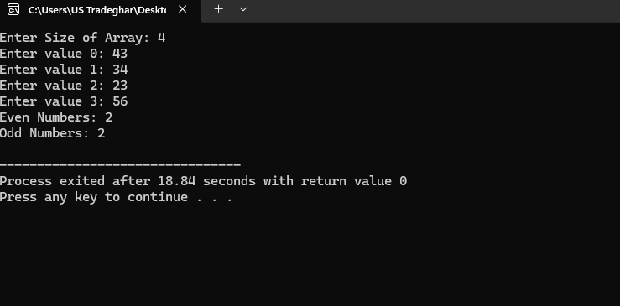

Task 2
#include <iostream>
using namespace std;

int main()
{
int r, c;

cout << "Enter Rows: ";
cin >> r;

cout << "Enter Columns: ";
cin >> c;

int arr[r][c];

for(int i = 0; i < r; i++)
{
for(int j = 0; j < c; j++)
{
cin >> arr[i][j];
}
}

cout << "Matrix:" << endl;

for(int i = 0; i < r; i++)
{
for(int j = 0; j < c; j++)
{
cout << arr[i][j] << " ";
}
cout << endl;
}

return 0;
}
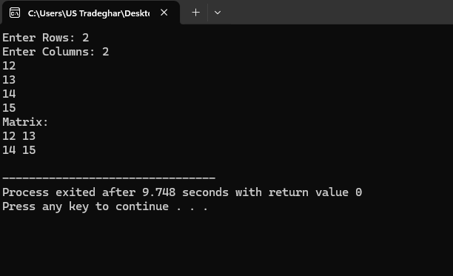
Task 3
#include <iostream>
using namespace std;

int findGCD(int a, int b)
{
while(b != 0)
{
int temp = b;
b = a % b;
a = temp;
}

return a;
}

int main()
{
cout << findGCD(48, 18);

return 0;
}
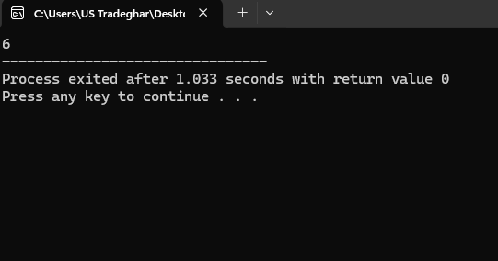

Task 4
#include <iostream>
using namespace std;

double calculateStrikeRate(int runs, int balls)
{
return (double)runs / balls * 100;
}

int main()
{
int runs, balls;

cin >> runs >> balls;

cout << "Strike Rate: " << calculateStrikeRate(runs, balls);

return 0;
}
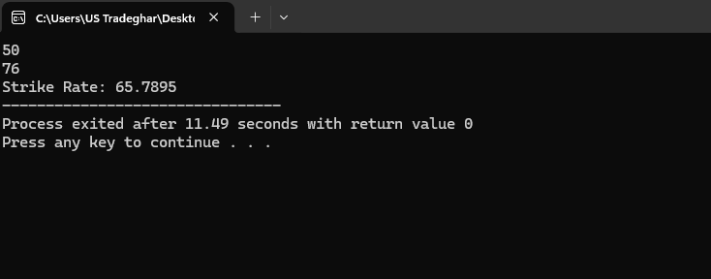

Task 5
#include <iostream>
using namespace std;

int getLength(char arr[])
{
int length = 0;

for(int i = 0; arr[i] != '\0'; i++)
{
length++;
}

return length;
}

int main()
{
char name[] = "Student";

cout << getLength(name);

return 0;
}
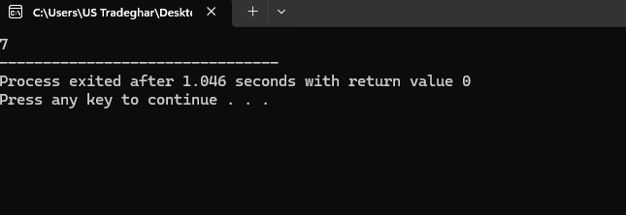

Task 6
#include <iostream>
using namespace std;

void copyWord(char src[], char dest[], int length)
{
for(int i = 0; i < length; i++)
{
dest[i] = src[i];
}

dest[length] = '\0';
}

int main()
{
char original[] = "Code";
char backup[10];

copyWord(original, backup, 4);

cout << backup;

return 0;
}
